HEADER FILES USED AND THEIR PURPOSE

**1. FSTREAM.H-** For file handling, cin and cout

**2. CONIO.H-** For clrscr() and getch() functions

**3. STDIO.H-**For standard I/O operations

**4. STRING.H-** For string handling

**5. PROCESS.H-** For exit(0) function

**6. IOMANIP.H-**For setw() functions

CODING

#include<conio.h>

#include<fstream.h>

#include<stdio.h>

#include<iomanip.h>

#include<string.h>

#include<process.h>

class order

{

public:

char description[50];

int n;

float price;

void display()

{

cout<<description<<setw(25)<<n<<setw(10)<<price<<endl;

}

};

void main()

{

int choice,r,c=0,tprice=0;

char address[50],name[30],ch;

order o[9];

clrscr();

cout<<setw(16)<<"WELCOME TO BITEME.COM"<<endl;

cout<<"Good food is always cooking!Go Ahead order some yummy items from your favourite restaurant"<<endl;

cout<<"Please enter your name : ";

gets(name);

cout<<"Please enter your address : ";

gets(address);

clrscr();

cout<<"Please choose your favourite restaurant :"<<endl;

cout<<"1.Haldiram's"<<endl;

cout<<"2.Pizza Hut"<<endl;

cout<<"3.Mc. Donalds"<<endl;

cout<<"4.Yo!China"<<endl;

cout<<"5.Dominos"<<endl;

cout<<"6.KFC"<<endl;

cout<<"7.Subway"<<endl;

cout<<"8.Burger King"<<endl;

cout<<"9.Starbucks"<<endl;

cout<<"10.Sagar Ratna"<<endl;

cin>>choice;

switch(choice)

{

case 1: {

clrscr();

cout<<"Welcome to Haldiram's!"<<endl;

cout<<"Please choose your favourite food item :"<<endl;

cout<<"MENU :"<<endl;

cout<<"1.Pani Puri - Rs.48"<<endl;

cout<<"2.Aloo Tikki - Rs.80"<<endl;

cout<<"3.Papdi Chaat - Rs.105"<<endl;

cout<<"4.Choley Bhature - Rs.130"<<endl;

cout<<"5.Pao Bhaji - Rs.130"<<endl;

cout<<"6.Bhel Puri - Rs.62"<<endl;

cout<<"7.Matar Kulcha - Rs.68"<<endl;

cout<<"8.Puri Sabzi Raita - Rs.97"<<endl;

cout<<"9.Chilli Potato - Rs.81"<<endl;

cout<<"10.Veg Fried Rice - Rs.99"<<endl;

do

{

cout<<"Please enter the item number : ";

cin>>r;

c=c+1;

switch (r)

{

case 1 :{

strcpy (o[c-1].description,"Pani Puri");

cout<<"How many items of this type do you need : ";

cin>>o[c-1].n;

o[c-1].price=(48)*(o[c-1].n);

break;

}

case 2 :{

strcpy (o[c-1].description,"Aloo Tikki");

cout<<"How many items of this type do you need : ";

cin>>o[c-1].n;

o[c-1].price=(80)*(o[c-1].n);

break;

}

case 3 :{

strcpy (o[c-1].description,"Papdi Chaat");

cout<<"How many items of this type do you need : ";

cin>>o[c-1].n;

o[c-1].price=(105)*(o[c-1].n);

break;

}

case 4 :{

strcpy (o[c-1].description,"Choley Bhature");

cout<<"How many items of this type do you need : ";

cin>>o[c-1].n;

o[c-1].price=(130)*(o[c-1].n);

break;

}

case 5 :{

strcpy (o[c-1].description,"Pao Bhaji");

cout<<"How many items of this type do you need : ";

cin>>o[c-1].n;

o[c-1].price=(130)*(o[c-1].n);

break;

}

case 6 :{

strcpy (o[c-1].description,"Bhel Puri");

cout<<"How many items of this type do you need : ";

cin>>o[c-1].n;

o[c-1].price=(62)*(o[c-1].n);

break;

}

case 7 :{

strcpy (o[c-1].description,"Matar Kulcha");

cout<<"How many items of this type do you need : ";

cin>>o[c-1].n;

o[c-1].price=(68)*(o[c-1].n);

break;

}

case 8 :{

strcpy (o[c-1].description,"Puri Sabzi Raita");

cout<<"How many items of this type do you need : ";

cin>>o[c-1].n;

o[c-1].price=(97)*(o[c-1].n);

break;

}

case 9 :{

strcpy (o[c-1].description,"Chilli Potato");

cout<<"How many items of this type do you need : ";

cin>>o[c-1].n;

o[c-1].price=(81)*(o[c-1].n);

break;

}

case 10 :{

strcpy (o[c-1].description,"Veg Fried Rice");

cout<<"How many items of this type do you need : ";

cin>>o[c-1].n;

o[c-1].price=(99)*(o[c-1].n);

break;

}

}

cout<<"Do you want to order more [y/n] : ";

cin>>ch;

}while(ch=='y');

break;

}

case 2: {

clrscr();

cout<<"Welcome to Pizza Hut!"<<endl;

cout<<"Please choose your favourite food item :"<<endl;

cout<<"MENU :"<<endl;

cout<<"1.Margherita - Rs.59 [Regular size]"<<endl;

cout<<"2.Veggie Delight - Rs.79 [Regular size]"<<endl;

cout<<"3.Farmhouse - Rs.169 [Medium size]"<<endl;

cout<<"4.Paneer Delight - Rs.200 [Large Size]"<<endl;

cout<<"5.Veg Extravaganza - Rs.400 [Large Size]"<<endl;

do

{

cout<<"Please enter the item number : ";

cin>>r;

c=c+1;

switch (r)

{

case 1 :{

strcpy (o[c-1].description,"Margherita [Regular size]");

cout<<"How many items of this type do you need : ";

cin>>o[c-1].n;

o[c-1].price=(59)*(o[c-1].n);

break;

}

case 2 :{

strcpy (o[c-1].description,"Veggie Delight [Regular size]");

cout<<"How many items of this type do you need : ";

cin>>o[c-1].n;

o[c-1].price=(79)*(o[c-1].n);

break;

}

case 3 :{

strcpy (o[c-1].description,"Farmhouse [Medium size]");

cout<<"How many items of this type do you need : ";

cin>>o[c-1].n;

o[c-1].price=(169)*(o[c-1].n);

break;

}

case 4 :{

strcpy (o[c-1].description,"Paneer Delight [Large size]");

cout<<"How many items of this type do you need : ";

cin>>o[c-1].n;

o[c-1].price=(200)*(o[c-1].n);

break;

}

case 5 :{

strcpy (o[c-1].description,"Veg Extravaganza [Large size]");

cout<<"How many items of this type do you need : ";

cin>>o[c-1].n;

o[c-1].price=(400)*(o[c-1].n);

break;

}

}

cout<<"Do you want to order more [y/n] : ";

cin>>ch;

}while(ch=='y');

break;

}

case 3: {

clrscr();

cout<<"Welcome to Mc. Donalds!"<<endl;

cout<<"Please choose your favourite food item :"<<endl;

cout<<"MENU :"<<endl;

cout<<"1.Mc. Aloo Tikki - Rs.32"<<endl;

cout<<"2.Masala Grill - Rs.58"<<endl;

cout<<"3.Mc. Spicy Paneer - Rs.128"<<endl;

cout<<"4.Mc. Veggie - Rs.75"<<endl;

cout<<"5.Veg. Maharaja Mac - Rs.145"<<endl;

cout<<"6.Veg McPuff - Rs.35"<<endl;

cout<<"7.Mc Egg - Rs.35"<<endl;

cout<<"8.Mc Double Tikki - Rs.129"<<endl;

cout<<"9.Mc Spicy Tikki - Rs.119"<<endl;

cout<<"10.Mc Spicy Chicken Supreme - Rs.135"<<endl;

do

{

cout<<"Please enter the item number : ";

cin>>r;

c=c+1;

switch (r)

{

case 1 :{

strcpy (o[c-1].description,"Mc. Aloo Tikki");

cout<<"How many items of this type do you need : ";

cin>>o[c-1].n;

o[c-1].price=(32)*(o[c-1].n);

break;

}

case 2 :{

strcpy (o[c-1].description,"Masala Grill");

cout<<"How many items of this type do you need : ";

cin>>o[c-1].n;

o[c-1].price=(58)*(o[c-1].n);

break;

}

case 3 :{

strcpy (o[c-1].description,"Mc. Spicy Paneer");

cout<<"How many items of this type do you need : ";

cin>>o[c-1].n;

o[c-1].price=(128)*(o[c-1].n);

break;

}

case 4 :{

strcpy (o[c-1].description,"Mc. Veggie");

cout<<"How many items of this type do you need : ";

cin>>o[c-1].n;

o[c-1].price=(75)*(o[c-1].n);

break;

}

case 5 :{

strcpy (o[c-1].description,"Veg Maharaja Mac");

cout<<"How many items of this type do you need : ";

cin>>o[c-1].n;

o[c-1].price=(145)*(o[c-1].n);

break;

}

case 6 :{

strcpy (o[c-1].description,"Veg McPuff");

cout<<"How many items of this type do you need : ";

cin>>o[c-1].n;

o[c-1].price=(35)*(o[c-1].n);

break;

}

case 7 :{

strcpy (o[c-1].description,"Mc Egg");

cout<<"How many items of this type do you need : ";

cin>>o[c-1].n;

o[c-1].price=(35)*(o[c-1].n);

break;

}

case 8 :{

strcpy (o[c-1].description,"Mc Double Tikki");

cout<<"How many items of this type do you need : ";

cin>>o[c-1].n;

o[c-1].price=(129)*(o[c-1].n);

break;

}

case 9 :{

strcpy (o[c-1].description,"Mc Spicy Tikki");

cout<<"How many items of this type do you need : ";

cin>>o[c-1].n;

o[c-1].price=(119)*(o[c-1].n);

break;

}

case 10 :{

strcpy (o[c-1].description,"Mc Spicy Chicken Supreme");

cout<<"How many items of this type do you need : ";

cin>>o[c-1].n;

o[c-1].price=(135)*(o[c-1].n);

break;

}

}

cout<<"Do you want to order more [y/n] : ";

cin>>ch;

}while(ch=='y');

break;

}

case 4: {

clrscr();

cout<<"Welcome to Yo!China !"<<endl;

cout<<"Please choose your favourite food item :"<<endl;

cout<<"MENU :"<<endl;

cout<<"1.Dimsum [10 pc.] - Rs.149"<<endl;

cout<<"2.Shezwan Mushroom Dimsum [10 pc.] - Rs.160"<<endl;

cout<<"3.Spring roll - [10 pc.] - Rs.159"<<endl;

cout<<"4.Chilly Potato - Rs.139"<<endl;

cout<<"5.Honey Chilly Potato - Rs.149"<<endl;

cout<<"6.Thai Vegetable Roll - Rs.219"<<endl;

cout<<"7.Thai Style Corn Pepper - Rs.319"<<endl;

cout<<"8.Chicken Shawarma - Rs.89"<<endl;

cout<<"9.Chives Dimsum - Rs.49"<<endl;

cout<<"10.Crisp Honey Chicken - Rs.489"<<endl;

do

{

cout<<"Please enter the item number : ";

cin>>r;

c=c+1;

switch (r)

{

case 1 :{

strcpy (o[c-1].description,"Dimsum [10 pc.]");

cout<<"How many items of this type do you need : ";

cin>>o[c-1].n;

o[c-1].price=(149)*(o[c-1].n);

break;

}

case 2 :{

strcpy (o[c-1].description,"Shezwan mushroom dimsum [10 pc.]");

cout<<"How many items of this type do you need : ";

cin>>o[c-1].n;

o[c-1].price=(160)*(o[c-1].n);

break;

}

case 3 :{

strcpy (o[c-1].description,"Spring roll [10 pc.]");

cout<<"How many items of this type do you need : ";

cin>>o[c-1].n;

o[c-1].price=(159)*(o[c-1].n);

break;

}

case 4 :{

strcpy (o[c-1].description,"Chilly Potato");

cout<<"How many items of this type do you need : ";

cin>>o[c-1].n;

o[c-1].price=(139)*(o[c-1].n);

break;

}

case 5 :{

strcpy (o[c-1].description,"Honey Chilly Potato");

cout<<"How many items of this type do you need : ";

cin>>o[c-1].n;

o[c-1].price=(149)*(o[c-1].n);

break;

}

case 6 :{

strcpy (o[c-1].description,"Thai Vegetable Roll");

cout<<"How many items of this type do you need : ";

cin>>o[c-1].n;

o[c-1].price=(219)*(o[c-1].n);

break;

}

case 7 :{

strcpy (o[c-1].description,"Thai Style Corn Pepper");

cout<<"How many items of this type do you need : ";

cin>>o[c-1].n;

o[c-1].price=(319)*(o[c-1].n);

break;

}

case 8 :{

strcpy (o[c-1].description,"Chicken Shawarma");

cout<<"How many items of this type do you need : ";

cin>>o[c-1].n;

o[c-1].price=(89)*(o[c-1].n);

break;

}

case 9 :{

strcpy (o[c-1].description,"Chives Dimsum");

cout<<"How many items of this type do you need : ";

cin>>o[c-1].n;

o[c-1].price=(49)*(o[c-1].n);

break;

}

case 10 :{

strcpy (o[c-1].description,"Crisp Honey Chicken");

cout<<"How many items of this type do you need : ";

cin>>o[c-1].n;

o[c-1].price=(489)*(o[c-1].n);

break;

}

}

cout<<"Do you want to order more [y/n] : ";

cin>>ch;

}while(ch=='y');

break;

}

case 5: {

clrscr();

cout<<"Welcome to Dominos !"<<endl;

cout<<"Please choose your favourite food item :"<<endl;

cout<<"MENU :"<<endl;

cout<<"1.Margherita Pizza - Rs.149"<<endl;

cout<<"2.Double Cheese Margherita Pizza - Rs.160"<<endl;

cout<<"3.Pepper Pizza - Rs.175"<<endl;

cout<<"4.Cheese & Barbeque Chicken Pizza - Rs.130"<<endl;

cout<<"5.Meatza Pizza - Rs.245"<<endl;

cout<<"6.Veg Singles Pizza - Rs.170"<<endl;

cout<<"7.Barbeque Chicken Pizza - Rs.175"<<endl;

cout<<"8.Zesty Chicken Pizza - Rs.210"<<endl;

cout<<"9.Veg Extravaganza Pizza - Rs.210"<<endl;

cout<<"10.Dominos Delux Pizza - Rs.269"<<endl;

do

{

cout<<"Please enter the item number : ";

cin>>r;

c=c+1;

switch (r)

{

case 1 :{

strcpy (o[c-1].description,"Margherita Pizza");

cout<<"How many items of this type do you need : ";

cin>>o[c-1].n;

o[c-1].price=(149)*(o[c-1].n);

break;

}

case 2 :{

strcpy (o[c-1].description,"Double Cheese Margherita Pizza");

cout<<"How many items of this type do you need : ";

cin>>o[c-1].n;

o[c-1].price=(160)*(o[c-1].n);

break;

}

case 3 :{

strcpy (o[c-1].description,"Pepper Pizza");

cout<<"How many items of this type do you need : ";

cin>>o[c-1].n;

o[c-1].price=(175)*(o[c-1].n);

break;

}

case 4 :{

strcpy (o[c-1].description,"Chesse & Barbeque Chicken Pizza");

cout<<"How many items of this type do you need : ";

cin>>o[c-1].n;

o[c-1].price=(130)*(o[c-1].n);

break;

}

case 5 :{

strcpy (o[c-1].description,"Meatza Pizza");

cout<<"How many items of this type do you need : ";

cin>>o[c-1].n;

o[c-1].price=(245)*(o[c-1].n);

break;

}

case 6 :{

strcpy (o[c-1].description,"Veg Singles Pizza");

cout<<"How many items of this type do you need : ";

cin>>o[c-1].n;

o[c-1].price=(170)*(o[c-1].n);

break;

}

case 7 :{

strcpy (o[c-1].description,"Barbeque Chicken Pizza");

cout<<"How many items of this type do you need : ";

cin>>o[c-1].n;

o[c-1].price=(175)*(o[c-1].n);

break;

}

case 8 :{

strcpy (o[c-1].description,"Zesty Chicken Pizza");

cout<<"How many items of this type do you need : ";

cin>>o[c-1].n;

o[c-1].price=(210)*(o[c-1].n);

break;

}

case 9 :{

strcpy (o[c-1].description,"Veg Extragavanza Pizza");

cout<<"How many items of this type do you need : ";

cin>>o[c-1].n;

o[c-1].price=(210)*(o[c-1].n);

break;

}

case 10 :{

strcpy (o[c-1].description,"Dominos Delux Pizza");

cout<<"How many items of this type do you need : ";

cin>>o[c-1].n;

o[c-1].price=(269)*(o[c-1].n);

break;

}

}

cout<<"Do you want to order more [y/n] : ";

cin>>ch;

}while(ch=='y');

break;

}

case 6: {

clrscr();

cout<<"Welcome to KFC !"<<endl;

cout<<"Please choose your favourite food item :"<<endl;

cout<<"MENU :"<<endl;

cout<<"1.Hot & Crispy [8 pc.] - Rs.630"<<endl;

cout<<"2.Hot & Crispy [4 pc.] - Rs.343"<<endl;

cout<<"3.Smoky Grilled - [6 pc.] - Rs.523"<<endl;

cout<<"4.Friendship Bucket - Rs.585"<<endl;

cout<<"5.Smoky Duo Bucket Meal - Rs.465"<<endl;

cout<<"6.Duo Bucket Meal - Rs.449"<<endl;

cout<<"7.Mingles Bucket Meal - Rs.229"<<endl;

cout<<"8.Triple Treat - Rs.599"<<endl;

cout<<"9.Boneless Stips-[3 pc.] - Rs.120"<<endl;

cout<<"10.Hot Wings - [4 pc.]- Rs.120"<<endl;

do

{

cout<<"Please enter the item number : ";

cin>>r;

c=c+1;

switch (r)

{

case 1 :{

strcpy (o[c-1].description,"Hot & Crispy [ 8 pc.]");

cout<<"How many items of this type do you need : ";

cin>>o[c-1].n;

o[c-1].price=(630)*(o[c-1].n);

break;

}

case 2 :{

strcpy (o[c-1].description,"Hot & Crispy [ 4 pc.]");

cout<<"How many items of this type do you need : ";

cin>>o[c-1].n;

o[c-1].price=(343)*(o[c-1].n);

break;

}

case 3 :{

strcpy (o[c-1].description,"Smoky Grilled [6 pc.]");

cout<<"How many items of this type do you need : ";

cin>>o[c-1].n;

o[c-1].price=(523)*(o[c-1].n);

break;

}

case 4 :{

strcpy (o[c-1].description,"Friendship Bucket");

cout<<"How many items of this type do you need : ";

cin>>o[c-1].n;

o[c-1].price=(585)*(o[c-1].n);

break;

}

case 5 :{

strcpy (o[c-1].description,"Smoky Duo Bucket Meal");

cout<<"How many items of this type do you need : ";

cin>>o[c-1].n;

o[c-1].price=(465)*(o[c-1].n);

break;

}

case 6 :{

strcpy (o[c-1].description,"Duo Bucket Meal");

cout<<"How many items of this type do you need : ";

cin>>o[c-1].n;

o[c-1].price=(449)*(o[c-1].n);

break;

}

case 7 :{

strcpy (o[c-1].description,"Mingles Bucket Meal");

cout<<"How many items of this type do you need : ";

cin>>o[c-1].n;

o[c-1].price=(229)*(o[c-1].n);

break;

}

case 8 :{

strcpy (o[c-1].description,"Triple Treat");

cout<<"How many items of this type do you need : ";

cin>>o[c-1].n;

o[c-1].price=(599)*(o[c-1].n);

break;

}

case 9 :{

strcpy (o[c-1].description,"Boneless Strips [3 pc.]");

cout<<"How many items of this type do you need : ";

cin>>o[c-1].n;

o[c-1].price=(120)*(o[c-1].n);

break;

}

case 10 :{

strcpy (o[c-1].description,"Hot Wings [4 pc.]");

cout<<"How many items of this type do you need : ";

cin>>o[c-1].n;

o[c-1].price=(120)*(o[c-1].n);

break;

}

}

cout<<"Do you want to order more [y/n] : ";

cin>>ch;

}while(ch=='y');

break;

}

case 7: {

clrscr();

cout<<"Welcome to Subway !"<<endl;

cout<<"Please choose your favourite food item :"<<endl;

cout<<"MENU :"<<endl;

cout<<"1.Veggie Patty - Rs.125"<<endl;

cout<<"2.Chatpata Chana - Rs.110"<<endl;

cout<<"3.Hara Bhara Kebab - Rs.110"<<endl;

cout<<"4.Paneer Tikka - Rs.125"<<endl;

cout<<"5.Mexican Patty - Rs.110"<<endl;

cout<<"6.Chicken Teriyaki - Rs.150"<<endl;

cout<<"7.Italian BMT - Rs.150"<<endl;

cout<<"8.Turkey & Chicken Ham - Rs.150"<<endl;

cout<<"9.Aloo Patty - Rs.125"<<endl;

cout<<"10.Subway Club - Rs.150"<<endl;

do

{

cout<<"Please enter the item number : ";

cin>>r;

c=c+1;

switch (r)

{

case 1 :{

strcpy (o[c-1].description,"Veggie Patty");

cout<<"How many items of this type do you need : ";

cin>>o[c-1].n;

o[c-1].price=(125)*(o[c-1].n);

break;

}

case 2 :{

strcpy (o[c-1].description,"Chatpata Chana");

cout<<"How many items of this type do you need : ";

cin>>o[c-1].n;

o[c-1].price=(110)*(o[c-1].n);

break;

}

case 3 :{

strcpy (o[c-1].description,"Hara Bhara Kebab");

cout<<"How many items of this type do you need : ";

cin>>o[c-1].n;

o[c-1].price=(110)*(o[c-1].n);

break;

}

case 4 :{

strcpy (o[c-1].description,"Paneer Tikka");

cout<<"How many items of this type do you need : ";

cin>>o[c-1].n;

o[c-1].price=(125)*(o[c-1].n);

break;

}

case 5 :{

strcpy (o[c-1].description,"Mexican Patty");

cout<<"How many items of this type do you need : ";

cin>>o[c-1].n;

o[c-1].price=(110)*(o[c-1].n);

break;

}

case 6 :{

strcpy (o[c-1].description,"Chicken Teriyaki");

cout<<"How many items of this type do you need : ";

cin>>o[c-1].n;

o[c-1].price=(150)*(o[c-1].n);

break;

}

case 7 :{

strcpy (o[c-1].description,"Italian BMT");

cout<<"How many items of this type do you need : ";

cin>>o[c-1].n;

o[c-1].price=(150)*(o[c-1].n);

break;

}

case 8 :{

strcpy (o[c-1].description,"Turkey & Chicken Ham");

cout<<"How many items of this type do you need : ";

cin>>o[c-1].n;

o[c-1].price=(150)*(o[c-1].n);

break;

}

case 9 :{

strcpy (o[c-1].description,"Aloo Patty");

cout<<"How many items of this type do you need : ";

cin>>o[c-1].n;

o[c-1].price=(125)*(o[c-1].n);

break;

}

case 10 :{

strcpy (o[c-1].description,"Subway Club");

cout<<"How many items of this type do you need : ";

cin>>o[c-1].n;

o[c-1].price=(150)*(o[c-1].n);

break;

}

}

cout<<"Do you want to order more [y/n] : ";

cin>>ch;

}while(ch=='y');

break;

}

case 8: {

clrscr();

cout<<"Welcome to Burger King !"<<endl;

cout<<"Please choose your favourite food item :"<<endl;

cout<<"MENU :"<<endl;

cout<<"1.Crispy Veg Burger - Rs.35"<<endl;

cout<<"2.Crispy Chicken Burger - Rs.49"<<endl;

cout<<"3.Fiery Rings - [8 pc.] - Rs.69"<<endl;

cout<<"4.Veggie Strips- [8 pc.] - Rs.49"<<endl;

cout<<"5.Veg Chilli Cheese Burger - Rs.109"<<endl;

cout<<"6.Chicken Nuggets - [8 pc.] - Rs.89"<<endl;

cout<<"7.Chicken Strips - [8 pc.] - Rs.129"<<endl;

cout<<"8.Chicken Tandoor Grilled Burger - Rs.129"<<endl;

cout<<"9.BK Veggie Burger - Rs.59"<<endl;

cout<<"10.BK Grilled Chicken Burger - Rs.69"<<endl;

do

{

cout<<"Please enter the item number : ";

cin>>r;

c=c+1;

switch (r)

{

case 1 :{

strcpy (o[c-1].description,"Crispy Veggie");

cout<<"How many items of this type do you need : ";

cin>>o[c-1].n;

o[c-1].price=(35)*(o[c-1].n);

break;

}

case 2 :{

strcpy (o[c-1].description,"Crispy Chicken Burger");

cout<<"How many items of this type do you need : ";

cin>>o[c-1].n;

o[c-1].price=(49)*(o[c-1].n);

break;

}

case 3 :{

strcpy (o[c-1].description,"Fiery Rings [8 pc.]");

cout<<"How many items of this type do you need : ";

cin>>o[c-1].n;

o[c-1].price=(69)*(o[c-1].n);

break;

}

case 4 :{

strcpy (o[c-1].description,"Veggie Strips [8 pc.]");

cout<<"How many items of this type do you need : ";

cin>>o[c-1].n;

o[c-1].price=(49)*(o[c-1].n);

break;

}

case 5 :{

strcpy (o[c-1].description,"Veg Chilli Cheese Burger");

cout<<"How many items of this type do you need : ";

cin>>o[c-1].n;

o[c-1].price=(109)*(o[c-1].n);

break;

}

case 6 :{

strcpy (o[c-1].description,"Chicken Nuggets [8 pc.]");

cout<<"How many items of this type do you need : ";

cin>>o[c-1].n;

o[c-1].price=(89)*(o[c-1].n);

break;

}

case 7 :{

strcpy (o[c-1].description,"Chicken Strips [8 pc.]");

cout<<"How many items of this type do you need : ";

cin>>o[c-1].n;

o[c-1].price=(129)*(o[c-1].n);

break;

}

case 8 :{

strcpy (o[c-1].description,"Chicken Tandoor Grilled Burger");

cout<<"How many items of this type do you need : ";

cin>>o[c-1].n;

o[c-1].price=(129)*(o[c-1].n);

break;

}

case 9 :{

strcpy (o[c-1].description,"BK Veggie Burger");

cout<<"How many items of this type do you need : ";

cin>>o[c-1].n;

o[c-1].price=(59)*(o[c-1].n);

break;

}

case 10 :{

strcpy (o[c-1].description,"BK Grilled Chicken Burger");

cout<<"How many items of this type do you need : ";

cin>>o[c-1].n;

o[c-1].price=(69)*(o[c-1].n);

break;

}

}

cout<<"Do you want to order more [y/n] : ";

cin>>ch;

}while(ch=='y');

break;

}

case 9: {

clrscr();

cout<<"Welcome to Starbucks !"<<endl;

cout<<"Please choose your favourite food item :"<<endl;

cout<<"MENU :"<<endl;

cout<<"1.Caramel Mocha - Rs.200"<<endl;

cout<<"2.Caffe Mocha - Rs.165"<<endl;

cout<<"3.Vanilla Latte - Rs.180"<<endl;

cout<<"4.Cappuccino - Rs.170"<<endl;

cout<<"5.Cocoa Cappuccino - Rs.230"<<endl;

cout<<"6.Americano - Rs.165"<<endl;

cout<<"7.Brewed Coffe - Rs.160"<<endl;

cout<<"8.White Mocha - Rs.205"<<endl;

cout<<"9.Signature Hot Chocolate - Rs.170"<<endl;

cout<<"10.Coffe Latte - Rs.189"<<endl;

do

{

cout<<"Please enter the item number : ";

cin>>r;

c=c+1;

switch (r)

{

case 1 :{

strcpy (o[c-1].description,"Caramel Mocha");

cout<<"How many items of this type do you need : ";

cin>>o[c-1].n;

o[c-1].price=(200)*(o[c-1].n);

break;

}

case 2 :{

strcpy (o[c-1].description,"Caffe Mocha");

cout<<"How many items of this type do you need : ";

cin>>o[c-1].n;

o[c-1].price=(165)*(o[c-1].n);

break;

}

case 3 :{

strcpy (o[c-1].description,"Vanilla Latte");

cout<<"How many items of this type do you need : ";

cin>>o[c-1].n;

o[c-1].price=(180)*(o[c-1].n);

break;

}

case 4 :{

strcpy (o[c-1].description,"Cappuccino");

cout<<"How many items of this type do you need : ";

cin>>o[c-1].n;

o[c-1].price=(170)*(o[c-1].n);

break;

}

case 5 :{

strcpy (o[c-1].description,"Cocoa Cappuccino");

cout<<"How many items of this type do you need : ";

cin>>o[c-1].n;

o[c-1].price=(230)*(o[c-1].n);

break;

}

case 6 :{

strcpy (o[c-1].description,"Americano");

cout<<"How many items of this type do you need : ";

cin>>o[c-1].n;

o[c-1].price=(165)*(o[c-1].n);

break;

}

case 7 :{

strcpy (o[c-1].description,"Brewed Coffe");

cout<<"How many items of this type do you need : ";

cin>>o[c-1].n;

o[c-1].price=(160)*(o[c-1].n);

break;

}

case 8 :{

strcpy (o[c-1].description,"White Mocha");

cout<<"How many items of this type do you need : ";

cin>>o[c-1].n;

o[c-1].price=(205)*(o[c-1].n);

break;

}

case 9 :{

strcpy (o[c-1].description,"Signature Hot Chocolate");

cout<<"How many items of this type do you need : ";

cin>>o[c-1].n;

o[c-1].price=(170)*(o[c-1].n);

break;

}

case 10 :{

strcpy (o[c-1].description,"Coffe Latte");

cout<<"How many items of this type do you need : ";

cin>>o[c-1].n;

o[c-1].price=(189)*(o[c-1].n);

break;

}

}

cout<<"Do you want to order more [y/n] : ";

cin>>ch;

}while(ch=='y');

break;

}

case 10: {

clrscr();

cout<<"Welcome to Sagar Ratna!"<<endl;

cout<<"Please choose your favourite food item :"<<endl;

cout<<"MENU :"<<endl;

cout<<"1.Rice Idli - Rs.125"<<endl;

cout<<"2.Dahi Idli - Rs.155"<<endl;

cout<<"3.Rava Idli - Rs.150"<<endl;

cout<<"4.Upma - Rs.110"<<endl;

cout<<"5.Idli Vada - Rs.150"<<endl;

cout<<"6.Masala Vada - Rs.155"<<endl;

cout<<"7.Plain Uttapam - Rs.160"<<endl;

cout<<"8.Tomato Uttapam - Rs.185"<<endl;

cout<<"9.Masala Dosa - Rs.170"<<endl;

cout<<"10.Veg Biryani - Rs.190"<<endl;

do

{

cout<<"Please enter the item number : ";

cin>>r;

c=c+1;

switch (r)

{

case 1 :{

strcpy (o[c-1].description,"Rice Idli");

cout<<"How many items of this type do you need : ";

cin>>o[c-1].n;

o[c-1].price=(125)*(o[c-1].n);

break;

}

case 2 :{

strcpy (o[c-1].description,"Dahi Idli");

cout<<"How many items of this type do you Need : ";

cin>>o[c-1].n;

o[c-1].price=(155)*(o[c-1].n);

break;

}

case 3 :{

strcpy (o[c-1].description,"Rava Idli");

cout<<"How many items of this type do you need : ";

cin>>o[c-1].n;

o[c-1].price=(150)*(o[c-1].n);

break;

}

case 4 :{

strcpy (o[c-1].description,"Upma");

cout<<"How many items of this type do you need : ";

cin>>o[c-1].n;

o[c-1].price=(110)*(o[c-1].n);

break;

}

case 5 :{

strcpy (o[c-1].description,"Idli Vada");

cout<<"How many items of this type do you need : ";

cin>>o[c-1].n;

o[c-1].price=(150)*(o[c-1].n);

break;

}

case 6 :{

strcpy (o[c-1].description,"Masala Vada");

cout<<"How many items of this type do you need : ";

cin>>o[c-1].n;

o[c-1].price=(155)*(o[c-1].n);

break;

}

case 7 :{

strcpy (o[c-1].description,"Plain Uttapam");

cout<<"How many items of this type do you need : ";

cin>>o[c-1].n;

o[c-1].price=(160)*(o[c-1].n);

break;

}

case 8 :{

strcpy (o[c-1].description,"Tomato Uttapam");

cout<<"How many items of this type do you need : ";

cin>>o[c-1].n;

o[c-1].price=(185)*(o[c-1].n);

break;

}

case 9 :{

strcpy (o[c-1].description,"Masala Dosa");

cout<<"How many items of this type do you need : ";

cin>>o[c-1].n;

o[c-1].price=(170)*(o[c-1].n);

break;

}

case 10 :{

strcpy (o[c-1].description,"Veg Biryani");

cout<<"How many items of this type do you need : ";

cin>>o[c-1].n;

o[c-1].price=(190)*(o[c-1].n);

break;

}

}

cout<<"Do you want to order more [y/n] : ";

cin>>ch;

}while(ch=='y');

break;

}

}

for(int i=0;i<c;i++)

{

tprice=tprice+o[i].price;

}

getch();

int m=0;

order s;

ofstream out;

out.open("order1.dat",ios::binary);

do

{

strcpy(s.description,o[m].description);

s.price=o[m].price;

s.n=o[m].n;

out.write((char*)&s,sizeof(s));

m++;

}while(m<c);

out.close();

clrscr();

cout<<"****************************BILL******************************"<<endl;

cout<<"Username : "<<name<<endl;

cout<<"Address : "<<address<<endl;

ifstream in;

in.open ("order1.dat",ios::binary|ios::in);

cout<<"Description"<<setw(25)<<"No. of items"<<setw(10)<<"Price"<<endl;

m=0;

while (in.read((char*)&s,sizeof(s)))

{

s.display();

m++;

}

in.close();

cout<<"Total amount : "<<tprice<<endl;

float discount;

discount=tprice/10;

cout<<"Online order discount [10%] : "<<discount<<endl;

tprice=tprice-discount;

cout<<"Net Payable amount : "<<tprice<<endl;

cout<<"Your order will be delivered hot 'n' fresh in 30 minutes"<<endl;

cout<<"THANK YOU!!"<<endl;

getch();

}

OUTPUTS

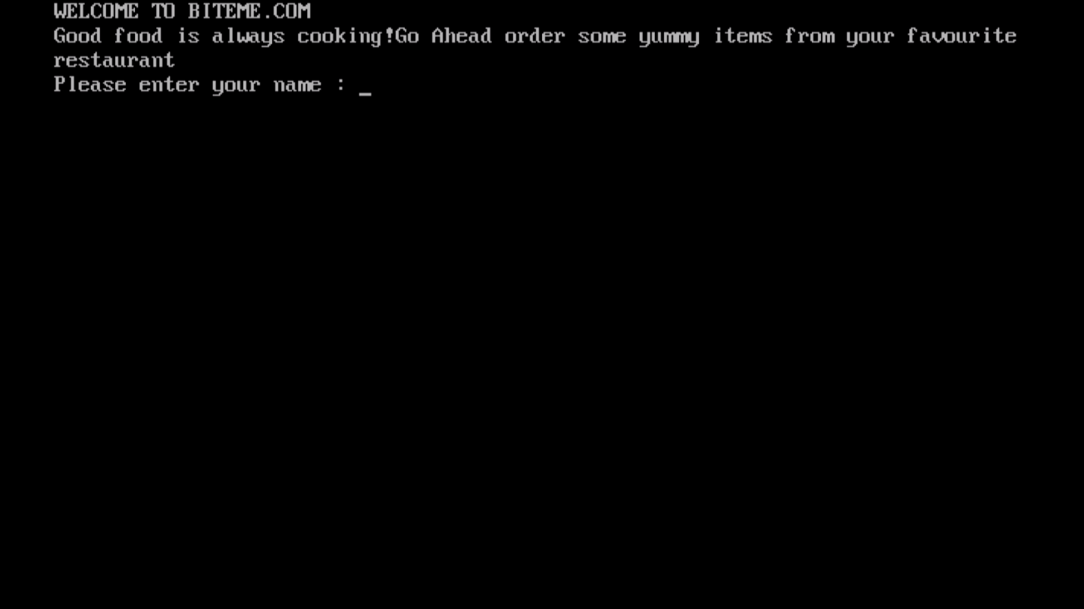

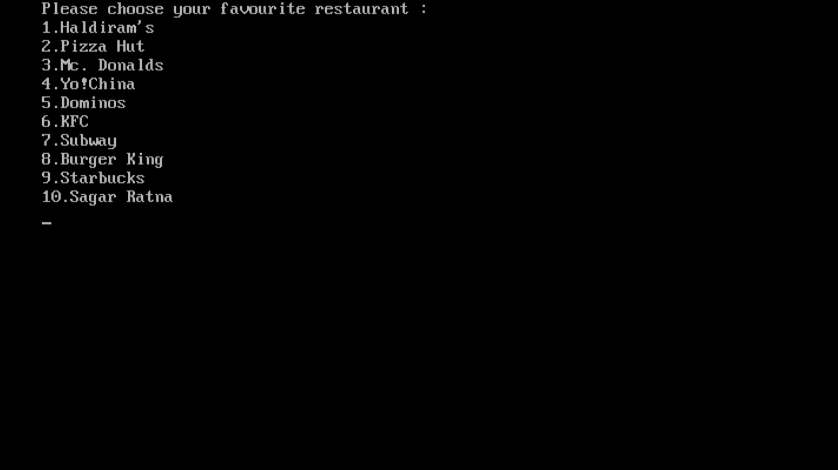

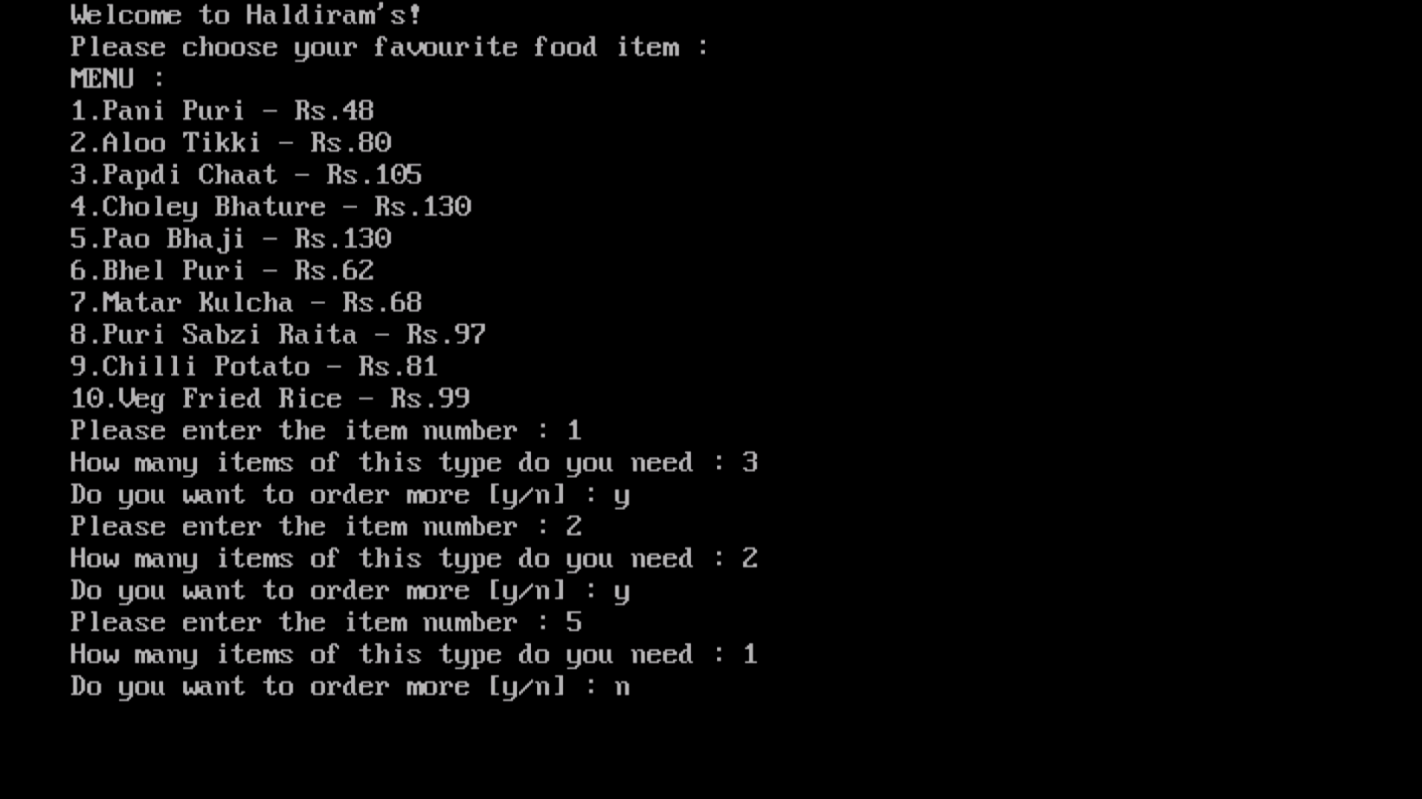

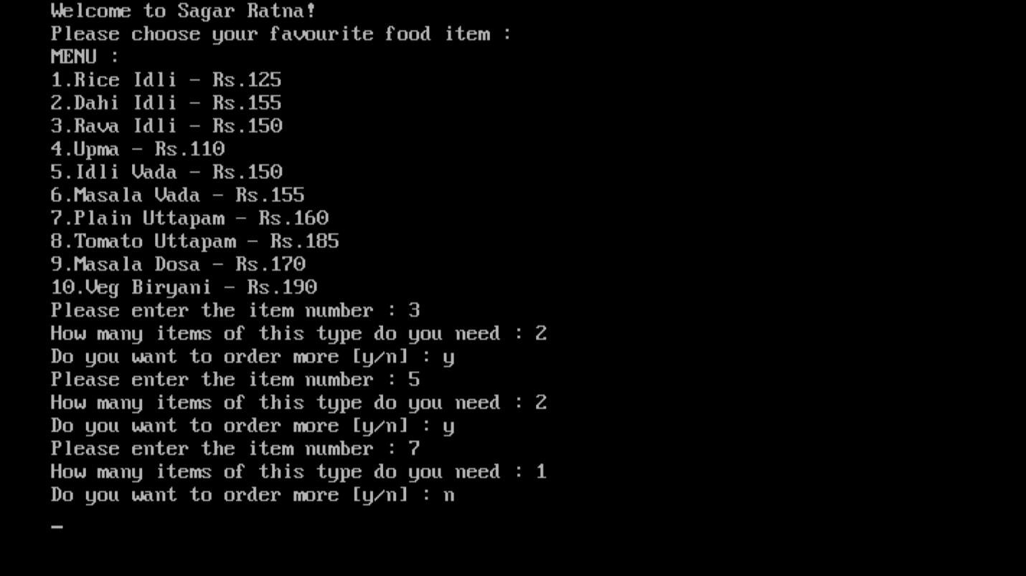

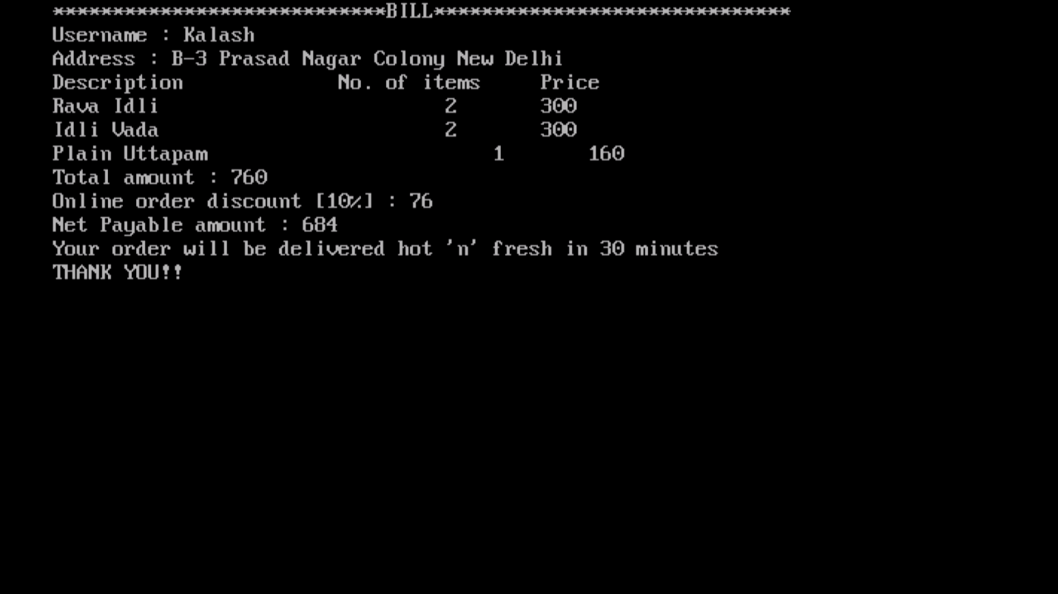

BIBLIOGRAPHY

* Computer Science with C++ by Sumita Arora
* www.google.com